**Table of Contents**

**1. Introduction** 2

**2. Analysis** 3

**3. System Requirements Specification (SRS)** 5

**3.1. Purpose** 5

**3.2 Defination** 8

**3.3. Prioritization** 11

**3.4 Functional Requirements** 8

**3.5 Non-functional Requirments** 8

**3.6. Hardware and Software requirements** 12

**3.7 Use Cases** 8

**4. System Architecture** 24

**5. Initial Class Diagram** 26

**6. Conclusion** 27

**7. References** 28

**Introduction:**

Analysis can be defined as a process of requirement verification, collection and reviewing of data and entity for a smooth operational development of the system. The information gathering includes correlating the components of the system under pre-defined structures of development life-cycles in use.

Analysis is the initial stage of beginning of any system development lifecycle. As for developers this stage helps to recognize the behavioral and functional aspects of the system aiding in familiarization with the system under development. Except for that analysis also aids in risk assessment and project scope definition.

The system currently under development is ‘Find Your Music’ for open discussion the minimal understanding of the project is show on a rich picture diagram below.

**2. Analysis:**

The sole purpose of starting a development with analysis is to meet client’s expectations with the system and to tally the requirements and expectations of the client with developers and the system itself. Analysis is an initial detailed document of the system which consists of the behavioral expects of the project to define how the project will stood when finished the impact the project will hold during and after development is finished. Simultaneously aiding on a good decision making or problem scope definition. Hence plays a vital role in any system development.

First stage on analysis is to identify the problem statement. Problem statement is a written requirement from client which explains about the expected system by the client. It is a good head start for the analyst to observe and have an estimate guess of what the system is going to be like. After definition of problem statement is carried out now it’s up to the development team to define a ‘problem scope’ which is defined as the main challenge or the requirement of the system to be developed. For an instance the system ‘Find Your Music’ is to provide musicians with a platform to control and sell their own content and have viewers and listener to have access to it so the problem scope of the system is to developed a web platform which lets two type user ‘Uploader’ and ‘Downloader’ to upload and download the content ‘music’.

As per standard analysis methodology SWOT analysis is being used for this project in order to identify the strength, weakness, opportunities, and threats for the system. Following the backbone structure laid out by SWOT analysis which was used for the physiological aspect of the system now the analysis is taken a step further by following a set of structured analysis methodologies (only one of the mentioned will be used) like Object Oriented, People Oriented, Organization Oriented and so on. Considering the feasible requirements of the data generated by our system ‘find your music’ object oriented methodology of analysis was chosen to be best for the system. OOA was figured out to be the best fit for the system currently in initial phase of the development due to the functionality of the system which tends to generate real life data and uses the generated data as a basis to carry out its functionality. For an instance the download portal regarded as a functionality of the system which takes real life audio and stores into a database for downloader to have access to it will require certain level of object orientation to handle the data in the implementation phase. As a build up to the implementation phase the system will be analyzed with OOA.

**Advantages of using OOA:**

* Helps in decomposition of the function and objects on a level of abstraction by removing the dependencies between the operations and their relation by which only the data can pass through the operations untempering of the functionality and object.
* Aids in encapsulation and data hiding for a system that cannot be altered by their related components but can be used freely.
* Aids in reusability of the objects and functionality aiding in low cost, time and resources.
* Supports spontaneous changes to the module/object/functionality in system without tempering the interrelated components.

Object-oriented analysis is further classified into three branches of its own, categorized behavior of the system to handle the data (functional), change due to the generation of the data that makes the system to have additional functionality (dynamic) and real life data that will be used as it is in the system by some sort of object initiation which won’t change itself but will work as a catalyst for the functional requirement (object modelling). All of which are listed below:

**Object Modeling:**

* Describes the general and static component of the system with the help of static modeling tool like class diagram.
* Identification of the classes and object in which the static attributes are grouped into.
* Identification of the relation between the grouped static component namely classes or objects.

**Dynamic Modelling:**

* Definition of the how an individual objects respond when invoked with data or events created internally.
* Aids in identification of events and activity of objects.
* Includes construction of dynamic modeling diagrams like state transfer diagrams.

**Functional Modelling:**

* Definition of the change in the behavior of the object and how the data tends to change the state of operation.
* Defines the states of operation and their purpose on the system.
* Includes the construction of data flow diagram to show the functional dependences among the data related by the system.

Before carrying on with the analysis of the system we are still not sure where the actual data is going to come from. Off course the data will come from users so considering users as the preliminary stake holders we should model our system according to their will. To know what the user want with the system we need to gather information about their understanding, expectation and review of the requirement already gathered which will also help in analyzing the data that from the user. The information gathering is done using some of methods defined in analysis frame-work of OOA. The methodology are described as follows:

* One-to-One interviews
* Observations
* Questionnaires
* Survey
* Focus Group

From above mentioned methods only One-to-One interview was conducted for gathering the information considering the project scale, time estimation and scope.

The primary stakeholders of the system ‘Musicians’ and ‘Listeners’ who will be actively using the platform were chosen for the one to one interview with the set of questions below. For the shake of time conservation and project requirement the interview was conducted with only one listener and only one musician.

For musician we selected a local musician namely “Anish Khadka” few questions asked to the interviewee is snipped as follow:

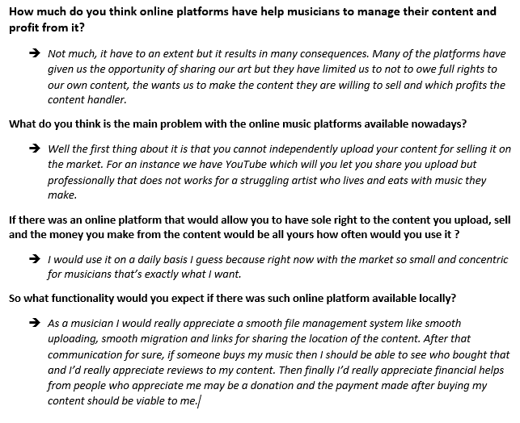

As a listener a local friend of the developer was interviewed, the interview snippet with few questions is as follows:

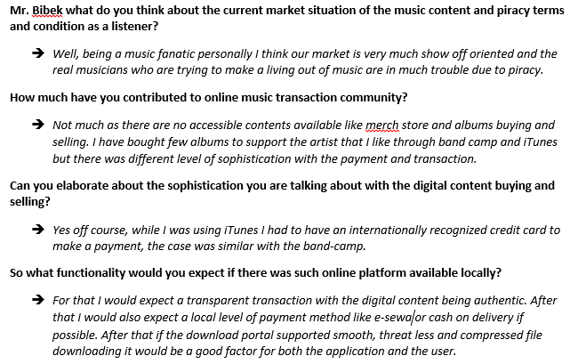

After analyzing what the users of the application wants from the application the development team decided to add some people oriented functionalities to the application. The features were as follows:

1). Integration of local payment portal in Find Your Music

2). A functionality to review the content uploaded by the artist by listener.

3). For efficiency of the listeners downloading experience addition of file compressor.

**3. System Requirement Specification:**

**3.1 SRS Purpose:**

System Requirement Specification is a documentation aspect of a system under development which lets all the stake holders to realize how the developed system’s function is going to behave or what are the requirement to make the system function as everyone wants.

**3.2 Definition:**

“A software requirements specification (SRS) is a comprehensive description of the intended purpose and environment for software under development. The SRS fully describes what the software will do and how it will be expected to perform.”- (Definition from searchsoftwarequality.techtarget.com).

**3.3 Functional Requirements:**

Functional requirement of any system is understood as the operational attribute of the system which acts as a backbone to the main functionality and features to the system. Functional requirements mainly includes the property of the system which completes certain operation after data transactions happens as aspect through the model of the system.

For the system ‘Find Your Musician’ the sketched functional requirement by the developer team is as follows.

|  |  |  |  |  |  |
| --- | --- | --- | --- | --- | --- |
| **Requirement ID** | **Description** | **Input** | **Output** | **Functionality Attribute** | **Remarks** |
| FYM-R-01 | User Registration | Informative data about the user(Name, Address, role, contribution) | Registration of the user with the system. | Creation of information about the user and it’s storage within the system. | Creation of user according to the role the user has (listener/artist) should be done |
| FYM-R-02 | Login | Username and Password | User Dashboard | Successful login | N/A |
| FYM-R-03 | Create |  |  |  |  |
| FYM-R-04 |  |  |  |  |  |
| FYM-R-05 |  |  |  |  |  |
| FYM-R-06 |  |  |  |  |  |
| FYM-R-07 |  |  |  |  |  |
| FYM-R-08 |  |  |  |  |  |
|  |  |  |  |  |  |
|  |  |  |  |  |  |
|  |  |  |  |  |  |

**References**:

* System Requirement Specification definition (‘https://www.inflectra.com/ideas/topic/requirements-definition.aspx’)  
  (‘https://www.dcslsoftware.com/how-to-write-a-system-requirement-specification/’)

(‘<https://searchsoftwarequality.techtarget.com/definition/software-requirements-specification>’)